New IAATO Procedures for Operating in the Vicinity of Whales

New IAATO Procedures for Operating in the Vicinity of Whales
Information Paper submitted by IAATO
Summary
IAATO operators have unanimously adopted mandatory procedures to mitigate ship strike risks from vessel operations in the Antarctic Peninsula region. This paper is a summary of the new IAATO actions that will commence in the 2019-2020 Antarctic season.
Background
While no cetacean population along the Antarctic Peninsula has been comprehensively assessed, anecdotal evidence and extremely high pregnancy rates (Pallin et al., 2018) suggest that humpback whale (Megaptera novaeangliae) populations are experiencing growth. With the Peninsula region being an area of significant human activity and recognizing that increased shipping has the potential to lead to an increase in whale strikes, especially in the whale rich waters of the Gerlache Strait, member operators of the International Association of Antarctica Tour Operators (IAATO) voted at their recent Annual Meeting in Cape Town, South Africa, May 2019, to adopt mandatory measures to mitigate ship strike risks from vessel operations. IAATO members plan their activities to have no more than a minor or transitory impact on the environment, an ethos that led them to act, despite the absence of comprehensive data to support spatial planning in the manner of van der Hoop et al. (2012), for example.
IAATO member operators represent the large majority of all tour operators operating in Antarctica, including all commercial SOLAS passenger ship operators. IAATO reports whale strikes to the International Whaling Commission. Nine strikes have been recorded since 2001.
New IAATO Procedures for Operations in the Vicinity of Whales
For the 2019-20 season, IAATO operators are instructed to commit to one of the following:
1. A 10kn speed restriction within geofenced time-areas (see Figure 1).
(This excludes emergency or other extenuating circumstances).
OR for IAATO operators who have a whale strike mitigation training program:
2. An extra watchman on the bridge for the sole purpose of being on whale lookout within the geofenced time-area proposed. Appropriate records of this action must be recorded in the ship’s log.
This is a mandatory measure: all IAATO operators will participate by taking one of these two actions during the 2019-20 season.
The geofenced time-areas are as follows:
• January 1 through May 30 in the Gerlache Strait and adjacent waters, in the area between 63.65°S and 65.35°S, including Dallmann Bay west to 64.2°W;
• February 1 through May 30 in the Marta Passage entering Crystal Sound, 67.8°W to 67.0°W.
Further, IAATO will take steps to study the implications of these procedures, including what observer-based whale strike mitigation training programs exist within IAATO operator bridge teams, and their expected efficacy, as well as information gaps that limit a more refined and evidence-based whale strike risk mitigation system.

Figure 1 – Geofenced time-areas where IAATO’s new procedures for operating in the vicinity of whales will apply.
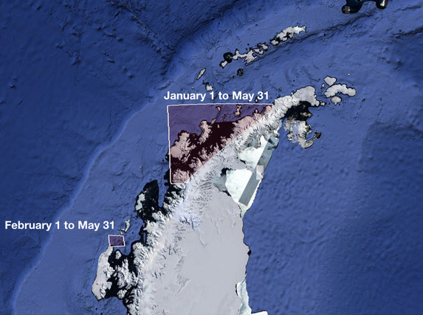

References
Pallin, L. J., Baker, C. S., Steel, D., Kellar, N. M., Robbins, J., Johnston, D. W., Friedlaender, A. S. (2018). High pregnancy rates in humpback whales (Megaptera novaeangliae) around the Western Antarctic Peninsula, evidence of a rapidly growing population. Royal Society Open Science, 5(5), 180017. https://doi.org/10.1098/rsos.180017
van der Hoop, J. M., Vanderlaan, A. S. M., & Taggart, C. T. (2012). Absolute probability estimates of lethal vessel strikes to North Atlantic right whales in Roseway Basin, Scotian Shelf. Ecological Applications, 22(7), 2021–2033. https://doi.org/10.1890/11-1841.1

