IAATO Overview of Antarctic Tourism: 2019-20 Season

IAATO Overview of Antarctic Tourism:
2019-20 Season
Information Paper Submitted by the
International Association of Antarctica Tour Operators (IAATO)

Introduction
IAATO is pleased to provide the statistical data compiled from Post Visit Reports for the 2019-20 season.
These figures are based on information provided to IAATO by its Operators as of 08 July, 2020. These numbers reflect only those travelling with IAATO Operator companies and do not include Observers, Government Officials, or those individuals taking part in research projects that are being supported by IAATO Operators.
IAATO’s Membership continues to encompass the majority of private-sector tour operators. Operator activities are permitted or authorized through Environmental Impact Assessments, Advance Notifications and, where relevant, Waste Management Permits, and submitted in advance of the season. Nearly all activities, which follow IAATO policies and guidelines, have been conducted on expeditions for more than a decade, and in many cases since the beginning of Antarctic tourism circa the 1960’s. IAATO Operators continue to work together to coordinate activities in advance, so that operations are conducted in a safe and environmentally responsible manner, and that activities are planned to have no more than a minor or transitory impact on the Antarctic environment.
For more information on IAATO Operator activities see ATCM XLII IP145 A Catalogue of IAATO Operator Activities.

1.0 General Overview
The 2019-20 season numbers (74,401 persons) were less than the forecast of 78,520 in ATCM XLII IP140 IAATO Overview of Antarctic Tourism 2018-19 and Preliminary Estimates for 2019-20 Season. This discrepancy is mainly attributed to one expected vessel not operating, as well as the 2019-20 season concluding earlier than normal due to the SARS CoV-2 pandemic. Final analysis of Post Visit Reports for the 2019-20 season indicates that there was a 32.5% increase in the overall IAATO tourism statistics from the 2018-19 season.

Shipborne tourism on the Peninsula remains the dominant vector of travel. The vast majority (95%) of tourism voyages operate in the Antarctic Peninsula region during the five-month austral summer season (from November to March), departing from Ushuaia, Argentina (72%) or, to a lesser extent, from other ports north of the Antarctic Treaty Area. There were no IAATO Operator over-flights to the Antarctic continent.

The Post Visit Report Forms submitted to IAATO indicate that more than 121 different nationalities were represented by tourists who visited the Antarctic during the 2019-20 season, with the top 10 nationalities listed in Table 1: Percentage of Passenger nationalities travelling with IAATO operators in the season 2019-2020

Table 1: Percentage of Passenger nationalities travelling with IAATO operators in the season 2019-2020

Nationality | Percentage of Total 2019-20 Season
United States | 36%
China | 11%
Australia | 11%
Germany | 8%
United Kingdom | 7%
Canada | 5%
France | 3%
Switzerland | 2%
Netherlands | 2%
New Zealand | 1%
Other | 14%

2.0 IAATO Seaborne Operations Overview
This section focuses on the Seaborne Operations for the 2019-20 season. Additional information on 2019-20 season and previous seasons, including activities and landing site use, are posted on the IAATO website (www.iaato.org). Additionally, selected site-specific information is available in ATIPxx Report on IAATO Operator Use of Antarctic Peninsula Landing Sites and ATCM Visitor Site Guidelines, 2019-20 Season.

2.1 IAATO Seaborne Activities
All commercial SOLAS passenger ship Operators that we are aware of conducting tourism activities in the Antarctic Treaty Area are currently members of IAATO. Table 2. 5-Year Statistics of Recorded Seaborne Tourism (including Cruise Only) offers a summary of the last five years of both IAATO SOLAS and non-SOLAS vessel tourism.
Table 2. 5-Year Statistics of Seaborne Tourism (including Cruise Only)
Based on IAATO Post Visit Report Forms.

Year | No. of operators | No. of ships &  yachts | No. of voyages | No. of passengers making landings | No. of cruise only passengers
2015-16 | 38 | 48 | 286 | 29,960 | 8,109
2016-17 | 38 | 47 | 298 | 36,440 | 7,475
2017-18 | 44 | 50 | 344 | 42,576 | 9,131
2018-19 | 44 | 56 | 360 | 44,600 | 10,889
2019-20 | 47 | 62 | 408 | 55,164 | 18,506

Figure 1: Commercial Operated Activities Conducted from Expedition Vessels and Yachts for 2019-20 illustrates activities offered by IAATO vessels including cruise-only and yachts, for 2019-2020. Small boat cruising and landing remain the most popular activities (58%) for vessels offering landings, while scenic ship cruising for both landing and cruise-only vessels also remains prevalent. A range of other activities (e.g kayaking and overnight stays) contribute to a smaller portion (9%) of off-ship activities.

In accordance with IAATO Bylaws, Operators are to employ experienced guides, at least 75% of which have worked previously in Antarctica. IAATO vessel Operators maintain a minimum of 20:1 field staff to passenger ratio when ashore. It is also strongly recommended that all Expedition Team members pass the relevant IAATO Field Staff Assessment annually to increase knowledge and understanding of IAATO, ATS guidelines and other relevant procedures. Staff and guides assist in the preparation of policies and guidelines; and ensure their implementation in the field, and sound education programmes on board.

Figure 1: Commercial Operated Activities Conducted from Expedition Vessels and Yachts for 2019-20
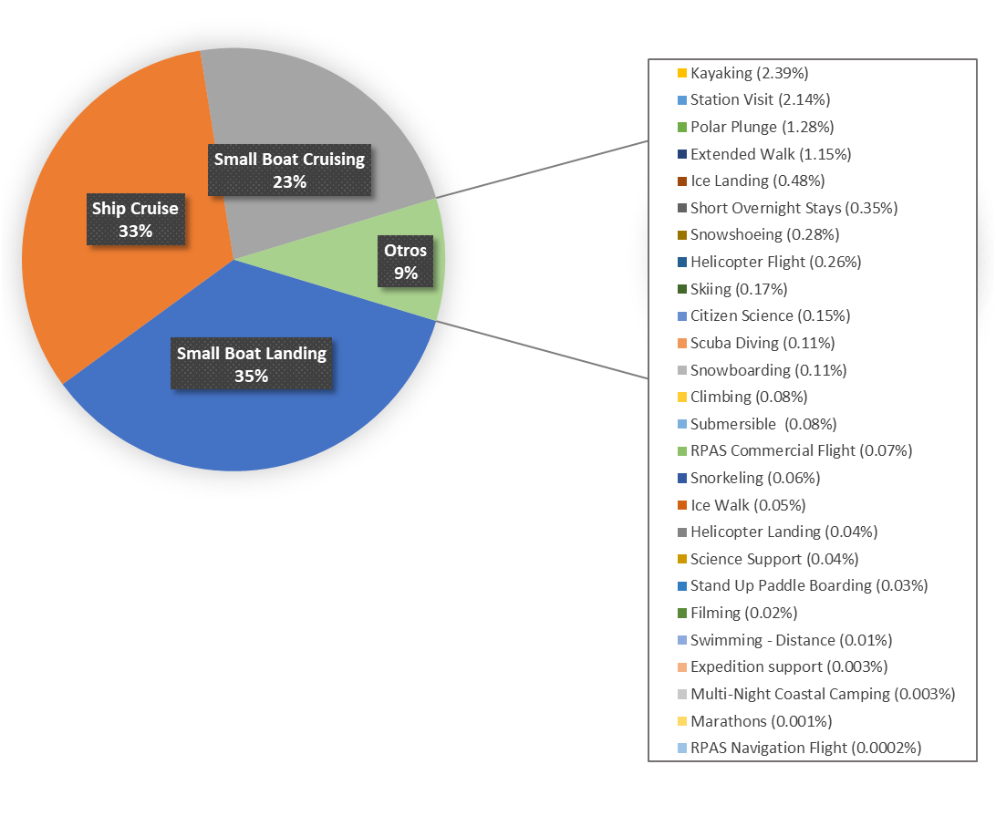

3.0 IAATO Deep Field and Air Tourism Overview
During the 2019-20 season, five IAATO Operators conducted deep field tourism activities. Table 3: Programs and Participant Numbers (clients) for 2015-20 offers additional information of those operations.
One Air Operator supported Air-Cruise expeditions based out of the South Shetland Islands. This Air Operator also offered single day or multi-day Antarctic experiences in the South Shetland Islands.
The six companies employed experienced guides; over 80% of which have worked previously in Antarctica. Staff and guides assist in the preparation of policies and guidelines; and ensure their implementation in the field.
Deep Field and Air Operators usually maintain a higher client to staff ratio than is typical for seaborne tourism– often in the region of 1 guide to every 3 clients. The exception is with solo expeditions, for example during South Pole Ski Expeditions, where the clients are supported remotely and closely monitored through communication protocols. All Deep Field and Air Operators prepare contingency plans for the health, safety, medical care and evacuation or their staff and clients.in line with Resolution 6 (2017).

3.1 Deep Field and Air Operations
Antarctic Logistics and Expeditions (ALE):
- One Ilyushin IL-76 was used to ferry general and hazardous cargo, wastes, fuel, staff, guides and passengers between SCCI Punta Arenas, Chile, or SAWH Ushuaia, Argentina, and SCGC Runway 18M Union Glacier.
- One Ilyushin IL-76-TD90 was used to make airdrops and to ferry general and hazardous cargo, wastes, fuel, and staff between SCCI Punta Arenas, Chile, and SCGC Runway 18M Union Glacier, and between SCGC Runway 18M Union Glacier and FACT Cape Town, South Africa.
- One Gulfstream Aerospace G-IV was used to ferry guides and passengers between SCCI Punta Arenas, Chile, and SCGC Runway 18M Union Glacier.
- Four ski-equipped DHC-6 Twin Otter aircraft and one ski-wheel configured Basler DC3-PT67 aircraft were used for flights within Antarctica and to provide medical evacuation support throughout the season.

The Antarctic Company (TAC):
- One Ilyushin IL-76 TD-90 was used to ferry general and hazardous cargo, wastes, fuel, staff, guides and passengers between Cape Town, South Africa and Novo Airbase.
- One ski-equipped DHC-6 Twin Otter aircraft and one Basler BT-67 aircraft were used for flights within Antarctica and to provide medical evacuation support throughout the season.
- One Boeing 757-200 for flights between Cape Town and Novo Airbase.
White Desert (WDL):
- One Gulf Stream G550 for flights between Cape Town and Wolf’s Fang
- One Basler BT-67 and one DCH-6 Twin Otter aircraft used for flights within Antarctica

3.2 Ground Transport
- ALE operated a number of tractor traverses, primarily for more efficient transport of fuel and cargo, and to support scientific activities.
- ALE, TAC, WDL and Arctic Trucks all used modified wheel and tracked vehicles

3.3 Camps (Primary)
- ALE Union Glacier Camp opened October 23, 2019 and closed February 04, 2020.
- TAC Novo Camp opened November 06, 2019 and closed on February 07, 2020.
- WDL Wolf’s Fang Camp opened November 04, 2019 and closed on February 25, 2020.

3.4 Programs and Activities
Activities including the operation of standard programs, the organization and operation of private expeditions, and logistical support of other expeditions for the last five seasons, are outlined in Table 3: Programs and Participant Numbers (clients) for 2015-20. Total numbers participating include clients from all five IAATO Deep Field and Air Operators. Note that some clients participated in multiple programs.

Table 3: Programs and Participant Numbers (clients) for 2015-20
(note some participants may take part in several programs)
Program | 2015-16 | 2016-17 | 2017-18 | 2018-19 | 2019-20
Emperor Penguin Colony Visits | 45 | 50 | 94 | 142 | 189
Deep Field Experiences (Camping, skiing, mountaineering skydiving, cycling, etc.) | 60 | 51 | 88 | 44 | 243
Deep Field Flights (e.g. to Pole of Inaccessibility) | 21 | 4 | 0 | 17 | 25
South Pole Fly-in | 107 | 71 | 100 | 172 | 278
South Pole Ski Expedition | 7 | 12 | 18 | 18 | 37
South Pole Motorised Expedition | 0 | 15 | 3 | 22 | 18
Last 1-2 Degree Expedition | 30 | 43 | 44 | 43 | 117
Antarctic Crossing (ski & motorised) | 2 | 18 | 7 | 0 | 27
Vinson Massif | 143 | 111 | 145 | 152 | 399
Marathon | 80 | 113 | 124 | 120 | 317

3.5 Over-flights operated by IAATO Operators.

For the 2019-20 season, there were no over-flights of Antarctica by IAATO Operators.

4.0 Preliminary Estimate of Planned Activities for the 2020-21 Season
Unlike previous years, Preliminary Estimates for the 2020-21 season are not included in this Information Paper. At the time of Preliminary Estimate collection, the world was in a very uncertain place due to the recent declaration of the global pandemic, and as time progressed it was clear the 2020-21 season of Antarctic Tourism would be be largely cancelled as a result of the SARS CoV-2 pandemic. How the industry will recover is yet to be seen, but the pandemic will continue to affect IAATO Operator activities for the 2021-22 season and possibly beyond. IAATO will continue to report statistics to the Treaty Parties as they become available.

5.0 Tourism Statistics
The following data is publicly available on the IAATO website (https://iaato.org/information-resources/data-statistics/visitor-statistics/). In order to better assist with delivering appropriate statistics for interested parties, those who wish to access the IAATO tourism statistics must now do so through a data access portal.
- Tourists by Nationality (Landed)
- Tourists by Nationality (Air and Cruise)
- Tourists by Nationality (All)
- Number of Vessel based Tourists per Site per Activity – Ross Sea Region
- Number of Vessel based Tourists per Site per Activity – Peninsula
- Number of Vessel based Tourists per Site per Activity – All Regions

Appendices:
- Appendix 1: Overview of Antarctic Tourism 2019-20

Appendix 1: Overview of Antarctic Tourism 2019-20

Based on information provided by IAATO Operators to the IAATO Secretariat as of July 8, 2020

SUMMARY OF ACTUALS for 2019-2020 SEASON
(All tourist types)
*Note all numbers and company status are subject to change and are based on reports as of
Types of Tourism | Number of Vessels | Number of Departures | Total Number of Passengers
IAATO Traditional Seaborne Tourism Peninsula | 36 | 289 | 49806
IAATO Seaborne Tourism Ross Sea / Continental | 4 | 7 | 514
IAATO Sailing Vessels / Yacht Tourism Peninsula | 12 | 23 | 165
IAATO Air-Cruise Peninsula | 13 | 79 | 4679
IAATO Large Ships/ Cruise - Only Peninsula | 6 | 13 | 18506
IAATO Deep - Field Tourism | 6 Operators | N/A | 731

IAATO Members Traditional Seaborne Tourism - Peninsula Region - 2019-2020
Vessel | Vessel Registry | Operator / Charterer | # Voyages | # of PAX
Bark Europa | Netherlands | Rederij Bark EUROPA B.V. | 4 | 157
Bremen | Bahamas | Hapag-Lloyd Cruises | 2 | 264
Corinthian | Malta | Grand Circle Corporation | 9 | 813
Expedition | Liberia | G Adventures | 11 | 1407
Fram | Norway | Hurtigruten AS | 7 | 1260
Greg Mortimer | Bahamas | Aurora Expeditions | 9 | 1063
Hamburg | Bahamas | Plantours Kreuzfahrten | 3 | 1042
HANSEATIC Inspiration | Malta | Hapag-Lloyd Cruises | 5 | 964
HANSEATIC Nature | Malta | Hapag-Lloyd Cruises | 6 | 1165
Hebridean Sky | Bahamas | Polar Latitudes | 8 | 818
Hondius | Netherlands | Oceanwide Expeditions | 12 | 1933
Island Sky | Bahamas | Noble Caledonia | 1 | 92
Island Sky | Bahamas | Polar Latitudes | 5 | 505
Island Sky | Bahamas | Zegrahm Expeditions | 1 | 91
L'Austral | Mata Utu | Ponant | 10 | 1894
Le Boreal | Mata Utu | Ponant | 10 | 1892
Le Lyrial | Mata Utu | Abercrombie & Kent USA, LLC | 4 | 674
Le Lyrial | Mata Utu | Ponant | 3 | 536
Le Soleal | Mata Utu | Ponant | 10 | 1922
Magellan Explorer | Bahamas | Antarctica21 | 1 | 70
Midnatsol | Norway | Hurtigruten AS | 12 | 4804
MS Roald Amundsen | Norway | Hurtigruten AS | 9 | 3623
National Geographic Explorer | Bahamas | Lindblad Expeditions | 10 | 1507
National Geographic Orion | Bahamas | Lindblad Expeditions | 9 | 925
Ocean Adventurer | Bahamas | Quark Expeditions | 7 | 841
Ocean Atlantic | Bahamas | Albatros Expeditions | 15 | 2578
Ocean Diamond | Bahamas | Quark Expeditions | 11 | 1938
Ocean Endeavour | Bahamas | Quark Expeditions | 11 | 2174
Ocean Nova | Bahamas | Antarctica21 | 3 | 212
Ortelius | Netherlands | Oceanwide Expeditions | 6 | 668
Plancius | Netherlands | Oceanwide Expeditions | 11 | 1206
Scenic Eclipse | Bahamas | Scenic Tours (USA) Inc | 9 | 1708
Sea Spirit | Bahamas | Poseidon Expeditions | 11 | 1135
Seabourn Quest | Bahamas | Seabourn Cruise Line Ltd. | 5 | 2093
Silver Cloud | Bahamas | Silversea Cruises Ltd. | 8 | 1889
Silver Explorer | Bahamas | Silversea Cruises Ltd. | 6 | 819
Silver Whisper | Bahamas | Silversea Cruises Ltd. | 1 | 327
Ushuaia | Togo | Antarpply Expeditions | 13 | 1056
World Explorer | Portugal | Quark Expeditions | 11 | 1741
 |  |  | 289 | 49806
IAATO Members Air-Cruise Tourism - Peninsula Region - 2019-2020
Vessel | Vessel Registry | Operator / Charterer | # Voyages | # of PAX
Greg Mortimer | Bahamas | Aurora Expeditions | 5 | 614
Hebridean Sky | Bahamas | Antarctica21 | 6 | 427
Legend | Panama | EYOS Expeditions Ltd. | 4 | 75
Magellan Explorer | Bahamas | Antarctica21 | 17 | 1176
MY Archimedes | Bermuda | EYOS Expeditions Ltd. | 3 | 41
MY Hans Hansson | Saint Vincent and the Grenadines | Quixote Expeditions | 5 | 47
MY Hanse Explorer | Antigua and Barbuda | "Hanse Explorer" GmbH and Co. KG | 3 | 36
Ocean Adventurer | Bahamas | Quark Expeditions | 8 | 812
Ocean Nova | Bahamas | Antarctica21 | 16 | 998
S/V Australis | Cook Islands | Ocean Expeditions Ltd | 2 | 14
S/V Ocean Tramp | Saint Vincent and the Grenadines | Quixote Expeditions | 6 | 35
World Explorer | Portugal | Quark Expeditions | 3 | 404
 |  |  | 78 | 4679
IAATO Members Yacht Tourism - Peninsula Region - 2019-2020
Vessel | Vessel Registry | Operator / Charterer | # Voyages | # of PAX
Braveheart | New Zealand | EYOS Expeditions Ltd. | 1 | 12
MY Oceans Seven | Cayman Islands | EYOS Expeditions Ltd. | 1 | 5
S/V Australis | Cook Islands | Ocean Expeditions Ltd | 2 | 11
S/V Golden Fleece | United Kingdom | Golden Fleece Expeditions Ltd. | 1 | 5
S/V Icebird | Cayman Islands | Icebird Expeditions | 2 | 12
S/V Pelagic Australis | British Virgin Islands | Pelagic Expeditions LTD | 2 | 15
S/V Podorange | London | Voile Australe | 2 | 13
S/V Santa Maria Australis | Germany | SIM Expeditions | 3 | 25
S/V Selma Expeditions | Poland | Selma Expeditions | 3 | 19
S/V Spirit of Sydney | St Vincent | Spirit of Sydney Expeditions Pty Ltd | 2 | 13
S/V Vaïhéré | France | Latitude Oceane | 3 | 28
Sarah W. Vorwerk | Germany | Spirit of Sydney Expeditions Pty Ltd | 1 | 7
 |  |  | 23 | 165
IAATO Cruise Only Tourism - Peninsula Region - 2019-2020
Vessel | Vessel Registry | Operator / Charterer | # Voyages | # of PAX
Amsterdam | Netherlands | Holland America Line | 1 | 1201
Azamara Pursuit | Malta | Celebrity Cruise Lines/Royal Carribbean/Azamara Cruises | 1 | 678
Celebrity Eclipse | Malta | Celebrity Cruise Lines/Royal Carribbean/Azamara Cruises | 2 | 5556
Coral Princess | Bermuda | Princess Cruises | 3 | 5895
Volendam | Netherlands | Holland America Line | 1 | 1125
Zaandam | Netherlands | Holland America Line | 5 | 6712
 |  |  | 13 | 21167
IAATO Members Seaborne Tourism – Continental/Ross Sea - 2019-2020
Vessel | Vessel Registry | Operator / Charterer | # Voyages | # of Passengers
Akademik Shokalskiy | Russia | Heritage Expeditions | 2 | 93
Bremen | Bahamas | Hapag-Lloyd Cruises | 1 | 129
Ortelius | Netherlands | Oceanwide Expeditions | 2 | 196
Spirit of Enderby | Russia | Heritage Expeditions | 2 | 96
 |  |  | 7 | 514
IAATO Members Deep-Field and Air Tourism - 2019-2020
Operator / Charterer | Country | Antarctic Area Visited | Actual # Voyages | Actual # of Passengers
Antarctic Logistics & Expeditions LLC | USA | Continental | 1 | 375
Arctic Trucks | United Kingdom | Continental | 1 | 3
DAP Antarctica | Chile | South Shetlands | 1 | 123
Icetrek Expeditions and Equipment | Australia | Continental | 1 | 11
The Antarctic Company (TAC) (Pty.) Ltd. | South Africa | Continental | 1 | 60
White Desert Ltd | United Kingdom | Continental | 1 | 159
 |  |  |  | 731

