Report on IAATO Operator Use of Antarctic Peninsula Landing Sites and ATCM Visitor Site Guidelines, 2019-20 Season

Report on IAATO Operator Use of Antarctic Peninsula Landing Sites and ATCM Visitor Site Guidelines, 2019-20 Season

Information Paper submitted by IAATO

Introduction
IAATO remains committed to reporting to the CEP and ATCM information on IAATO Operator Landing Site and ATCM Visitor Site Guidelines use. This information paper presents data collected by IAATO from IAATO Operator Post Visit Report Forms for the Antarctic Peninsula during the 2019-20 season. No non-IAATO visits are included in this analysis.
Additional information on IAATO operator activities can be found in ATIP_IPxx IAATO Overview of Antarctic Tourism 2019-20 Season and on the IAATO website https://iaato.org/information-resources/data-statistics/.

Antarctic Peninsula traditional seaborne tourism
Antarctic tourism continues to be primarily focused on traditional commercial seaborne (SOLAS Vessels) tourism in the Antarctic Peninsula, which accounts for over 95% of all landed activity.
A SOLAS vessel (as defined in Maritime Rule Part 21) is any ship to which the International Convention for the Safety of Life at Sea 1974 applies; namely: a passenger ship engaged on an international voyage, or a non-passenger ship of 500 tons gross tonnage or more engaged on an international voyage. In this paper’s number analysis, yacht (vessels carrying 12 passengers or less) numbers are only included where specifically mentioned.

Figure 1: Factor Change in Traditional Landing Ship-borne Tourism in the Antarctic Peninsula 1989-2020 provides a comparison of the factor increase in different aspects of this activity (number of passengers, ships, voyages, landings made and sites used).

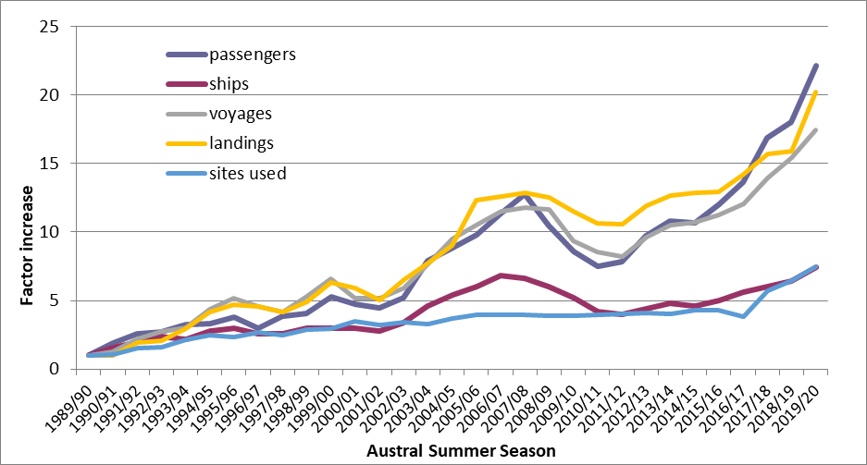
Figure 1: Factor Change in Traditional Landing Ship-borne Tourism in the Antarctic Peninsula 1989-2020.

In 2019-2020 all traditional commercial seaborne tourism with landings in the Peninsula was conducted by IAATO Operators and is believed to reflect actual activity levels during the reporting period. Through number analysis of the 2019-20 season, we have identified the following trends and influences:

Table 1: Number of IAATO SOLAS Vessels, on the Antarctic Peninsula for the past five years, 2015-2020.
Season | 2015/16 | 2016/17 | 2017/18 | 2018/19 | 2019/20
SOLAS Vessels | 25 | 28 | 30 | 32 | 37

- Since the Polar Code was adopted, there has been substantial investment by operators in existing and new built vessels. The 2019-20 season saw the first influx of vessels ships built after the Polar Code came into force in January 2017.
- The continued growth in activity is driven by increased interest and awareness of Antarctica resulting in a desire by many of the public to experience the region first hand.
- In 2019-2020 the IAATO fleet increased by ten SOLAS vessels offset by the withdrawal of five vessels that had operated in previous seasons (Appendix I) bringing the total number of vessels to 37. This increase in capacity is also reflected in the growing number of voyages (Table 2).

Table 2: Comparison between number passengers, voyages, landings and sites on the Antarctic Peninsula for the past five years, 2015-2020.
Season | 2015/16 | 2016/17 | 2017/18 | 2018/19 | 2019/20 | % Change 18/19 – 19/20
Passengers | 29493 | 33580 | 41517 | 44303 | 54485 | 23%
Voyages | 236 | 253 | 293 | 324 | 367 | 13%
Landings | 2206 | 2427 | 2679 | 2717 | 3223 | 19%
Sites | 125 | 111 | 166 | 187 | 215 | 15%

- Vessels are being operated with higher passenger capacity, with all vessels benefiting from the world economic strength and operating at near-full passenger capacity, until the announcement of the SARS-CoV-2 pandemic.

- The increase in the number of voyages is proportional to the increase of vessels.

- Analysis of site use and activities (found in ATIPxx IAATO Overview of Antarctic Tourism 2019-20 Season) has found Operators are choosing to spread site activities across a range of options – ship cruising; Zodiac cruising; kayaking; etc. IAATO has encouraged this practice over the past several years and at our 2019 Annual Meeting incorporated into our Bylaws a new Code of Conduct for Vessels that facilitates adoption of similar practices by all IAATO Operators.

Specific Landing Site Use
The five top sites visited during the 2019-2020 season (Neko Harbour, Cuverville Island, Halfmoon Island - Chinstrap Colony, Whalers Bay and Goudier Island) accounted for 25% of landings made during the season. The top twenty most-visited sites accounted for circa 62% of the landings.
Appendix II lists the 20 most-visited sites in terms of landings made and passengers for the 2019-20 season, while comparing the numbers to the 2018-19 season.
Figure 2 illustrates the total number of landings made per day at all sites within the Antarctic Peninsula during the 2019-20 season. Landings occurred in the Antarctic Treaty Area from 18 October 2019 – 21 March 2020 (a total of 155 days). This decrease in days (down from 174 for the 2018 -19 season) is due to the SARS-CoV-2 pandemic.

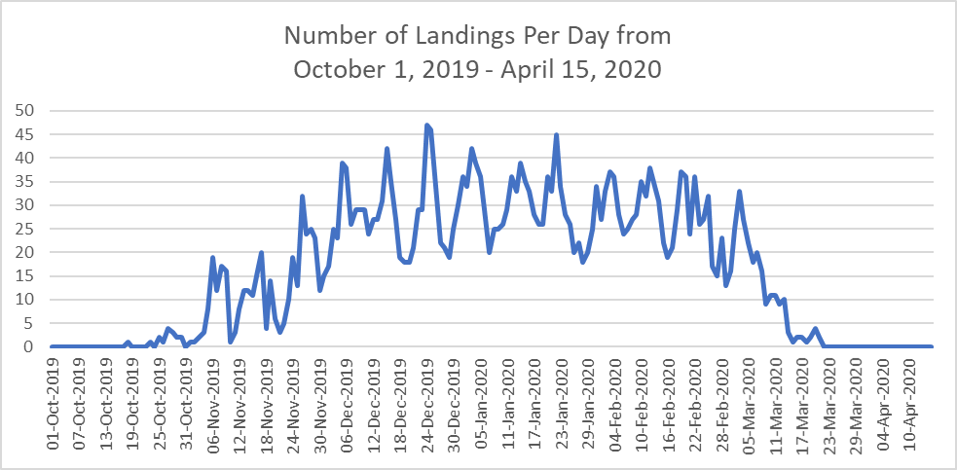

Figure 2: Total number of IAATO Operator landings made per day on the Antarctic Peninsula during the 2019-20 season.

As in previous seasons, there is variation in levels of activity; for example, in the peak of the season (December and January) the highest number of landings made on any one day (24 December) was 47, while the lowest number in the same period was 19 landings (29 December). These peaks and troughs are remarkably similar to last season indicating that the increase in activity has been spread across the season rather than intensifying pressure during the peak season.
Additional tourism statistics are available on the IAATO website: https://iaato.org/information-resources/data-statistics/
Use of ATCM Visitor Site Guidelines
Appendix III illustrates the total number of known landings made at sites covered by ATCM Visitor Site Guidelines, including a listing of the number of occasions the daily visitation limits were met. An assessment of the use of the sites covered by the ATCM Visitor Site Guidelines was conducted through an analysis of the Post Visit Report Forms.

As with previous seasons, analysis of the Post Visit Report Forms indicates that the daily limits set in the site guidelines were honoured during the 2019-20 season.

Conclusion
The information extracted from the ATCM Post Visit Reports for traditional commercial ship-borne tourism in the Antarctic Peninsula shows that overall tourism levels continue to rise. The increase is not uniform across all visitor sites however, with a few sites continuing to receive the majority of the increase, and others seeing a decrease in activity. The pattern of concentrated increase is believed to be partially explained by the popularity of these sites for their reliable access, ease of visitor management and aesthetic value. Additionally, factors such as ice patterns and weather strongly contribute to site selection and visitation patterns.
All of the top twenty landing sites on the Peninsula are managed by ACTM Visitor Site Guidelines or through National Program Management guidelines.
It is important to note the 2019-20 season was abruptly cut short by approximately two weeks due to the SARS-CoV-2 pandemic. It is likely the 2021-22 season will also be affected by the pandemic, and will not reflect recent tourism trends.
IAATO will continue to provide information annually to the CEP and ATCM on its Operators’ activities. In addition, IAATO Operators remain interested in gaining a better understanding of the use of ATCM Visitor Site Guidelines by non-IAATO visitors.

Appendices

Appendix I: IAATO Cat 1 and Cat 2 Vessel withdrawals/additions between the 2018-19 and 2019-20 seasons

Appendix II: Top Twenty Most-Visited Sites during the 2019-20 Season (including yacht visits), with comparison with 2018-19 Season

Appendix III: Site use covered by the ATCM Visitor Site Guidelines during the 2019-20 season.

Appendix I: IAATO Category 1 and Category 2 Vessel withdrawals/additions between the 2018-19 and 2019-20 seasons.

IAATO Cat 1&2 Vessels Additions | IAATO Cat 1&2 Vessels Withdrawn
Corinthian** - Category 1 | Akademik Ioffe – Category 1
Greg Mortimer – Category 1 | Akademik Vavilov – Category 1
Hanseatic Nature – Category 1 | Kaptain Khlebnikov – Category 1
Hanseatic Inspiration – Category 1 | Polar Pioneer – Category 1
Hondius – Category 1 | RCGS Resolute – Category 1
Magellan Explorer – Category 1
Roald Amundsen – Category 2
Scenic Eclipse – Category 1 or 2
Silver Whisperer – Category 2
World Explorer – Category 1

** An IAATO vessel that operated prior to 2018-19, did not Operate during the 2018-19 season, and returned to the fleet in 2019-20.

Appendix II: Top Twenty Most Visited Sites during the 2019-20 Season (including yacht visits) and number of landed passengers with comparison to 2018-19 Season
All of the most visited sites are covered by site specific management plans, either through ATCM Visitor Site Guidelines or National Program management through their proximity to stations.
Rank 2019-20 | Landing Site | 2018-19 Landed Visits | 2019-2020 Landed Visits | % Change | 2018-19 Landed Tourists | 2019-2020 Landed Tourists | % Change
1 | Neko Harbor | 157 | 191 | 22% | 23,789 | 24,363 | 2%
2 | Cuverville Island | 160 | 173 | 8% | 22,187 | 17,785 | -20%
3 | Half Moon Island - Chinstrap Colony | 131 | 155 | 18% | 18,298 | 21,161 | 16%
4 | Whalers Bay | 149 | 147 | -1% | 18,167 | 16,427 | -10%
5 | Goudier Island | 174 | 131 | -25% | 18,062 | 12,623 | -30%
6 | Danco Island | 107 | 112 | 5% | 19,123 | 16,108 | -16%
7 | Portal Point | 64 | 112 | 75% | 8,256 | 12,540 | 52%
8 | Petermann Island | 55 | 107 | 95% | 5,811 | 12,360 | 113%
9 | Damoy Point/Dorian Bay | 86 | 95 | 10% | 12,710 | 10,560 | -17%
10 | Brown Bluff | 56 | 90 | 61% | 8,375 | 12,194 | 46%
11 | Brown Station | 122 | 90 | -26% | 17,967 | 10,254 | -43%
12 | Mikkelsen Harbor (D'Hainaut) | 89 | 86 | -3% | 9,229 | 9,873 | 7%
13 | Port Charcot | 50 | 80 | 60% | 4,831 | 6,335 | 31%
14 | Jougla Point | 95 | 79 | -17% | 7,041 | 7,102 | 1%
15 | Orne Harbor | 58 | 76 | 31% | 7,910 | 8,891 | 12%
16 | Yankee Harbor | 53 | 65 | 23% | 6,658 | 8,619 | 29%
17 | Telefon Bay | 71 | 57 | -20% | 11,259 | 6,741 | -40%
18 | Vernadsky Station | 45 | 55 | 22% | 3,370 | 4,380 | 30%
19 | Waterboat Point/Gonzalez Videla Station | 47 | 54 | 15% | 7,842 | 7,626 | -3%
20 | Aitcho Islands - Barrientos Island | 42 | 52 | 24% | 5,895 | 5,243 | -11%

Appendix III: Recorded Site Use at Sites during the 2019-20 season covered by ATCM Visitor Site Guidelines.

Landing Site | 2019-20
Landing Site | Total Number of Landings | Number of days when maximum visit limitation was met
Ardley Island | 11 | 0
Astrolabe Island | 9 | 0
Baily Head | 18 | 2
Barrientos (Aitcho) Island | 52 | 9
Brown Bluff | 90 | 3
Cape Denison | 0 | 0
Cape Evans | 5 | 0
Cape Hallett | 1 | 0
Cape Royds | 4 | 0
Cuverville Island | 173 | 17
Damoy Point / Dorian Bay | 95 | 6
Danco Island | 112 | 4
Detaille Island | 20 | 1
Devil Island | 15 | 1
D'Hainaut (Mikkelsen Harbour) | 86 | 3
George’s Point (Ronge Island) | 28 | 0
Goudier (Port Lockroy) Island | 131 | 7
Halfmoon Island – Chinstrap Colony | 155 | 6
Hannah Point & Walker Bay | 8 | 8
Horseshoe Island | 14 | 2
Jougla Point | 79 | 1
Neko Harbour | 191 | 13
Orne Harbour | 76 | 4
Orne Islands | 22 | 0
Paulet Island | 49 | 6
Pendulum Cove | 26 | 0
Penguin Island | 16 | 2
Petermann Island | 107 | 0
Pleneau Island | 37 | 1
Point Wild | 2 | 0
Portal Point | 112 | 5
Port Charcot | 80 | 19
Shingle Cove | 2 | 0
Snow Hill Island, Nordenskjold’s hut | 2 | 2
Stonington Island | 9 | 0
Taylor Valley / Canada Glacier | 2 | 0
Telefon Bay | 57 | 1
Torgersen Island | 8 | 7
Turret Point | 7 | 0
Whalers Bay | 147 | 6
Wordie House | 25 | 2
Yalour Islands | 22 | 5
Yankee Harbour | 65 | 2

