IAATO 2018 ~ Newport
10kn Voluntary Speed Limit in Gerlache Strait and adjacent whale-rich waters during whale season

Proposal

During the season of high abundance of humpback whales on the Antarctic Peninsula, this proposal is to adopt a voluntary speed limit of 10kn for travel in the whale-rich waters of the Gerlache Strait and surrounding navigable waters:
- January 1 through May 30 in the Gerlache Strait and adjacent waters, in the area between 63.65S and 65.35S, including Dallmann Bay west to 64.2W
- February 1 through May 30 in the Marta Passage entering Crystal Sound, 67.8W to 67.0W
Further, I propose to convene scientists and naturalists over the next one to two years to study if, for example, areas of the Bransfield etc deserve consideration, if there are areas within the above which do not warrant the voluntary speed limit, or if other adaptive measures are warranted in addition to or in place of speed limits to minimize the risk of ship strikes to Antarctic marine mammals.

Rationale

In the words of whale biologist Dr. Ari Friedlaender:

"Vessel strikes are a serious risk to cetaceans around the world, and the Antarctic is no different. There is clear evidence to support that reductions in speed can dramatically decrease the risk to whales from ship-strikes. Given the investment that we all have in ensuring that the Antarctic ecosystem remains as unaffected by our actions as possible, it seems sensible that if we can do something to remove a potential threat like ship-strikes that we act accordingly. We are learning enough about these animals both in the Antarctic and elsewhere to understand that there are different risks to whales depending on their behavior, as well as the behavior of ships. Being proactive about decreasing vessel speeds in areas where whales are known to occur in high densities is a great first step towards minimizing any negative impacts that we have on Antarctic whales. This action would set a precedent for the continued unified, responsible and respectful actions of the Antarctic tourist/scientific community."

Ships strikes have proven to be one of the greatest causes of human-induced mortality for large whales. The extent of the problem is extremely difficult to assess in poorly studied Antarctic waters, however with very high densities of large whales, particularly humpback and minke whales, the probability is extremely high that IAATO vessels could cause fatal or severely injurious ship strikes to large whales in Antarctic waters.

20th century industrial whaling killed over 2,000,000 whales in the southern hemisphere, including over 215,000 humpback whales. After many decades of absence, humpbacks are showing a very strong recovery, and come seasonally to the inshore waters of the Antarctic Peninsula for a bonanza of feeding on krill. We all recognize that the predictability of seeing whales is a major attraction for Antarctic tourism. We cannot let ourselves be a threat to the animals that attract our travelers.

In the interest of maintaining a less than minor or transitory impact for Antarctic tourism, I believe responsible operations dictate that ships operating in whale-rich waters should reduce speed to a maximum of 10kn.

Why 10 knots? According to Vanderlaan and Taggart (2007), the probability of a collision causing a whale's death increases rapidly and in a non-linear manner as vessel speed increases; between the speeds of 9 and 20 knots, the probability of collision causing a whale's death rises from 20 to 100 percent, respectively. 10kn is the speed limit adopted for mandatory limits on the US East Coast for conservation of endangered North Atlantic Right Whale (full text of the US Federal Register rule copied below).

Alternative strategies to reduce the risk of ship strikes on whales have been proposed, principally centered around increased observer presence on the bridge during transits. However, studies in temperate latitudes have demonstrated that observer-based risk management is ineffective due to a number of factors, (1) ships cannot respond quickly enough to take evasive action, (2) observer-based risk management is inconsistently applied, observers may not have the skills and/or interest to consistently manage operations, and may not have sufficient independent authority to dictate a speed reduction, and (3) successful observation requires good visibility and low wind, conditions that are often lacking in the Antarctic. Most critically for IAATO vessel operations, for observer-based risk management to be accommodated by operations without inducing a schedule failure, sufficient time would need to be built into a schedule for a possible speed reduction. If the time must be built into the schedule to begin with, I believe it is wise for IAATO vessels to adhere to the more clearly successful, consistent, and operationally simple standard of a 10kn speed limit within the proposed time-area windows.

Most ship strikes go undetected. A full grown humpback whale weighs about 30 tonnes, less than 1% of the weight of a typical Category I IAATO vessel. We know ship strikes are a major cause of whale mortality, for example, almost 15% of living humpback whales on the US East Coast show ship strike injuries, but very few show injuries penetrating muscle, indicating that at an injury depth of penetrating muscle, the whale is unlikely to survive. It is evident that (1) ship traffic can be lethal to whales, (2) that the frequency and severity of ship strikes increases with speed (see attached graph modeling the likelihood of a strike being lethal, as a function of speed), and (3) that with both increasing whale numbers and increasing ship traffic on the Antarctic Peninsula, the risk of harmful impacts on Antarctic whales is increasing. Therefore I conclude that a speed limit is the right operational choice for the sake of protecting Antarctic whales and maintaining a high standard of environmentally responsible operations.

The science behind the impact of vessel traffic on Antarctic whale individuals and populations is extremely difficult, but not impossible. The above proposal is made in full recognition of scientific uncertainty, and for this reason proposes a simple time-area closure based on current apparent densities of whales. With the adoption of this proposal, I will work with as broad as possible an array of data sources and collaborators, to refine our understanding of the distribution and timing of whale populations in navigable Antarctic waters to improve risk management of potential ship strikes by IAATO vessels.

For reference, text from the final rule in the Federal Register (50 CFR 224), wi th the National Marine Fisheries Service (NMFS) basis for a 10kn speed limit:

"(A) Evidence and Justification: NMFS examined the best available scientific information in determining that the use of speed restrictions would be an effective means to reduce the likelihood and severity of ship strikes, and has set the limit for the restrictions based upon this evidence. Based on inventories of all known collisions between ships and large whale species, including right whales (Knowlton and Kraus, 2001; Laist et al., 2001; Jensen and Silber, 2003), Vanderlaan and Taggart (2007) examined all records for which ship speed at the time of impact was known. Based on their analysis, these authors concluded that the probability of a collision causing a whale's death increased rapidly and in a non-linear manner as vessel speed increased. They found that between the speeds of 9 and 20 knots, the probability of collision causing a whale's death rose from 20 to 100 percent, respect ively. The greatest increase occurred between the speeds of 10 and 14 knots. They determined that the probability of death occurring from a collision was approximately 35-40 percent at 10 knots, 45-60 percent at 12 knots, and 60-80 percent at 14 knots (Vanderlaan and Taggart, 2007). This analysis did not control for ship size. In an independent analysis using 64 records of ship strikes in which vessel speed was known, Pace and Silber (2005) tested speed as a predictor of the probability of a whale death or serious injury. They found strong evidence that the probability of death or serious injury increased rapidly with increasing vessel speed. Specifically, the predicted probability of serious injury or death increased from 45 percent to 75 percent as vessel speed increased from 10 to 14 knots, and exceeded 90 percent at 17 knots.

"In a compilation of ship strikes of all large whale species that assessed ship speed as a factor in ship strikes, Laist et al. (2001) concluded that a direct relationship existed between the occurrence of a whale strike and the speed of the vessel. These authors indicated that most deaths occurred when a vessel was traveling at speeds of 14 knots or greater and that, as speeds declined below 14 knots, whales apparently had a greater opportunity to avoid oncoming vessels. Adding to the Laist et al. (2001) study, Jensen and Silber (2003) compiled 292 records of known or probable ship strikes of all large whale species from 1975 to 2002. Vessel speed at the time of the collision was reported for 58 of those cases. Operating speeds of vessels that struck various species of large whales ranged from 2-51 knots with an average speed of 18.1 knots. A large majority (85.5 percent) of these strikes occurred at vessel speeds of 10 knots or greater.

"With regard to right whales specifically, the speeds of vessels were known with a high degree of certainty in two cases; in three other cases possibly involving right whales vessel speeds are also known. A juvenile right whale was killed on January 5, 1993, in waters off north Florida by an 82-ft (24.9-m) vessel operating at 15 knots. In waters off Cumberland Island, Georgia in March 2005, a 43-ft (13.1-m) vessel struck a right whale and severely injured the animal by nearly completely severing one lobe of its tail flukes. The boat was traveling at 20 knots and based on the whale's poor condition when last seen in summer 2005, it is presumed that the whale died. In winter 1972-73, a bulbous bow container ship traveling at 21-23 knots east of Boston, Massachusetts collided with and killed an unidentified whale thought possibly to have been a right whale (Laist et al., 2001). A whale calf, also possibly a right whale, was killed on July 6, 1991, off Delaware Bay by a ship traveling at 22 knots.

"In November 2004, a Federal vessel traveling 21 knots outside the mouth of the Chesapeake Bay reported hitting a whale. A severely injured right whale in the area of the collision was reported a few hours later and, although not linked definitively to the strike, a dead adult right whale with massive injuries washed ashore in northern North Carolina about a week later.

"Not all ship strikes are detected or documented. The right whale records identified above are only those in which the species, vessel speed, and fate of the animal were known. Records of vessel collisions with large whales are numerous, involve a number of species, variety of vessel types, and occur in various geographic locations (Jensen and Silber, 2003; Van Waerebeek and Leaper, 2008). For example, Van Waerebeek and Leaper (2008) recently identified 763 such records, worldwide. As noted above, for North Atlantic right whales alone, Nelson et al. (2007) determined that there were an average of 1.8 known right whale ship strike deaths and serious injuries per year in U.S. eastern seaboard, adjacent Canadian Maritimes, and Gulf of Mexico waters between 1999 and 2005. Glass et al. (2008) documented an average of 2.4 per year for the same waters in the years 2002 to 2006. In a separate analysis, Vanderlaan and Taggart (2007) concluded that right whales are far more vulnerable, per capita, to ship strikes than other large whale species.

"Effects of vessel speed on collision risks also have been studied using computer simulation models to assess hydrodynamic forces vessels have on a large whale (Knowlton et al., 1995; Knowlton et al., 1998). These studies found that, in certain instances, hydrodynamic forces around a vessel can act to pull a whale toward a ship. These forces increase with increasing speed and thus a whale's ability to avoid a ship in close quarters may be reduced with increasing vessel speed. Related studies by Clyne (1999) found that the number of simulated strikes with passing ships decreased with increasing vessel speeds, but that the number of strikes that occurred in the bow region increased with increasing vessel speeds.

"In measuring the forces involved in whale/ship collisions using whale and ship models in a tow tank, Slutsky (2007) determined that the magnitude of forces exerted on the whale increased linearly as vessel speed increased.

"In a modeling study using data from actual observed encounters of right whales with vessels, Kite-Powell et al. (2007) determined that more than half of right whales located in or swimming into the path of an oncoming ship traveling at 15 knots or greater are likely to be struck even if the whale takes evasive action. However, the strike risk posed by a conventional ship moving 20 to 25 knots could be reduced by 30 percent by slowing to 12 or 13 knots, and by 40 percent at 10 knots, due to the whales' increased ability to detect and avoid approaching vessels.

"Campbell-Malone (2007) examined the bio-mechanical properties of rig ht whale mandibles as related to blunt force trauma inflicted by a vessel. Citing Kite-Powell et al. (2007), Campbell-Malone (2007) indicated that there are compound (both behavioral and force of impact) benefits to implementing speed restrictions, and concluded that both studies predict a reduction of right whale deaths as a result of vessel speed limits in right whale habitat.

"With regard to the comment that whales are more likely to move away from vessels traveling fast because they are emitting more noise than slower ships, Nowacek et al. (2003) used a multi-sensor acoustic recording tag to measure the responses of right whales to passing ships and found that right whales showed little or no response to playback sounds of approaching vessels or actual vessels, regardless of vessel speed.

"With regard to comments that serious injury to a whale is a function more of vessel mass, rather than vessel speed, and that a large vessel hitting a whale at any speed could cause serious injury, NMFS believes that the analysis conducted by Vanderlaan and Taggart (2007) indicates that the force striking a whale is likely more a function of vessel speed and mass of the whale, rather than vessel mass. In an analysis of vessel mass versus vessel speed and the likelihood and severity of injury to manatees, Calleson and Frohlich (2007) concluded that vessel speed, not mass, was the most critical factor. They calculated, for example, that a doubling of the speed of a vessel would quadruple the amount of impact energy to the manatee, while quadrupling the speed would increase the amount of energy by a factor of 16.

"With regard to the comment that the records of vessel speeds at which ship strikes occur are a reflection of the speeds vessels travel generally, Pace and Silber (2005) compared the distribution of speeds at which known ship strikes occurred with the distribution of speeds of ships reporting into the Man datory Ship Reporting systems, which they considered representative of speeds that ships travel in general. The authors found that these two distributions were significantly different, suggesting that ship strikes involved vessels that were traveling faster than vessels tended to travel overall.

"Finally, NMFS is not aware of any data or studies that would contradict those cited above. No data, studies, or analyses were provided in the public comments demonstrating either that high vessel speeds would reduce the threat of ship collisions with right whales or that slow speeds would not reduce the likelihood or severity of a strike.

"Vessel speed restrictions have been used in efforts to protect endangered marine species other than right whales. For example, such restrictions have been used by the U.S. Fish and Wildlife Service to reduce watercraft collisions with manatees. In an analysis of the effectiveness of one such program, Laist and Shaw (2 006) concluded that manatee deaths were substantially reduced after slow speed restrictions were imposed throughout a Florida waterway that had been one of the deadliest areas in the state for watercraft related manatee deaths. Whereas watercraft-related manatee deaths had averaged 2.34 per year in the 42 months before the measures went into effect in June 2002, they were reduced to 0.29 per year in the 42 months after they went into effect.

"Vessel speed restrictions have also been established to protect other endangered large whale species. The National Park Service adopted regulations implementing a 13-knot speed limit for vessels in Glacier Bay National Park and Monument, Alaska, to reduce the likelihood of hitting humpback whales (National Park Service, 2003). Analyses of its effectiveness are not yet available. However, owners of a cruise ship that killed a humpback whale in Glacier Bay while exceeding the speed limit agreed to pay a substantial fine for exceeding the speed limit there.

"In an experiment to determine the effects of vessel speed and the incidence of collisions involving marine turtles, Hazel et al. (2007) determined that vessel speed was a significant factor in the likelihood of a strike and concluded that mandatory vessel speed restrictions were necessary to reduce the risk of strikes to sea turtles.

"As a result of a number of ship strike deaths of blue whales in waters off southern California, vessel speed advisories of 10 knots or less were provided by the USCG, in collaboration with NMFS and the Channel Islands National Marine Sanctuary, within 20 nm of the entrances to the ports of Los Angeles and Long Beach.

"Elsewhere, Panigada et al. (2006) concluded that vessel speed restrictions and the re-location of vessel routes in high cetacean density areas would reduce the likelihood of ship strikes of fin whales in the Mediterranean Sea.

"Based on the analysis indicating the conservation value of reduced vessel speeds and after considering concerns and information submitted in response to the ANPR and NPRM, NMFS has determined that a 10-knot speed restriction would significantly reduce the risk of serious or lethal collisions for right whales in areas where such speed restrictions would apply, also reducing potential economic hardship on the maritime industry.. Therefore, NMFS has concluded, based on the best available scientific evidence, that a maximum speed of 10 knots, as measured as “speed over ground”, in times and locations specified below, is the most effective and practical approach to reducing the threat of ship strikes to right whales. Ten knots therefore is the speed required by these regulations.

Timeline

Proposed to be effective for the 2018-2019 Antarctic season

Appendixes:
Appendix A: two images of an endangered North Atlantic right whale killed by a ship strike (credit: NOAA) (separate email)
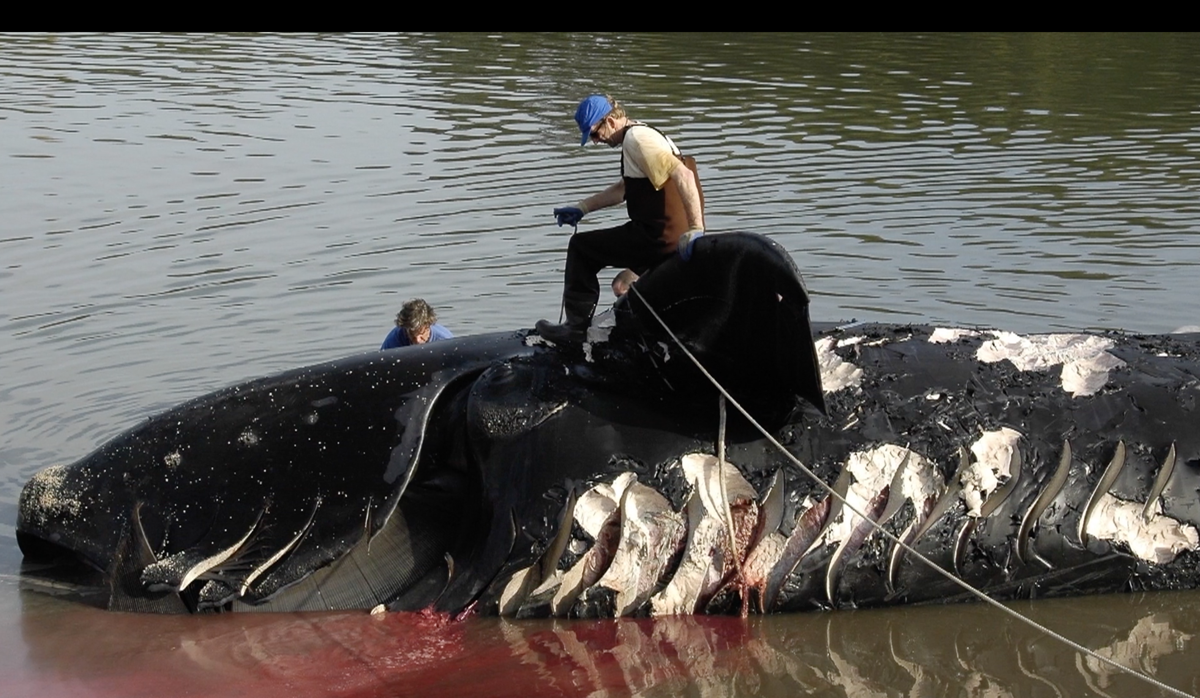
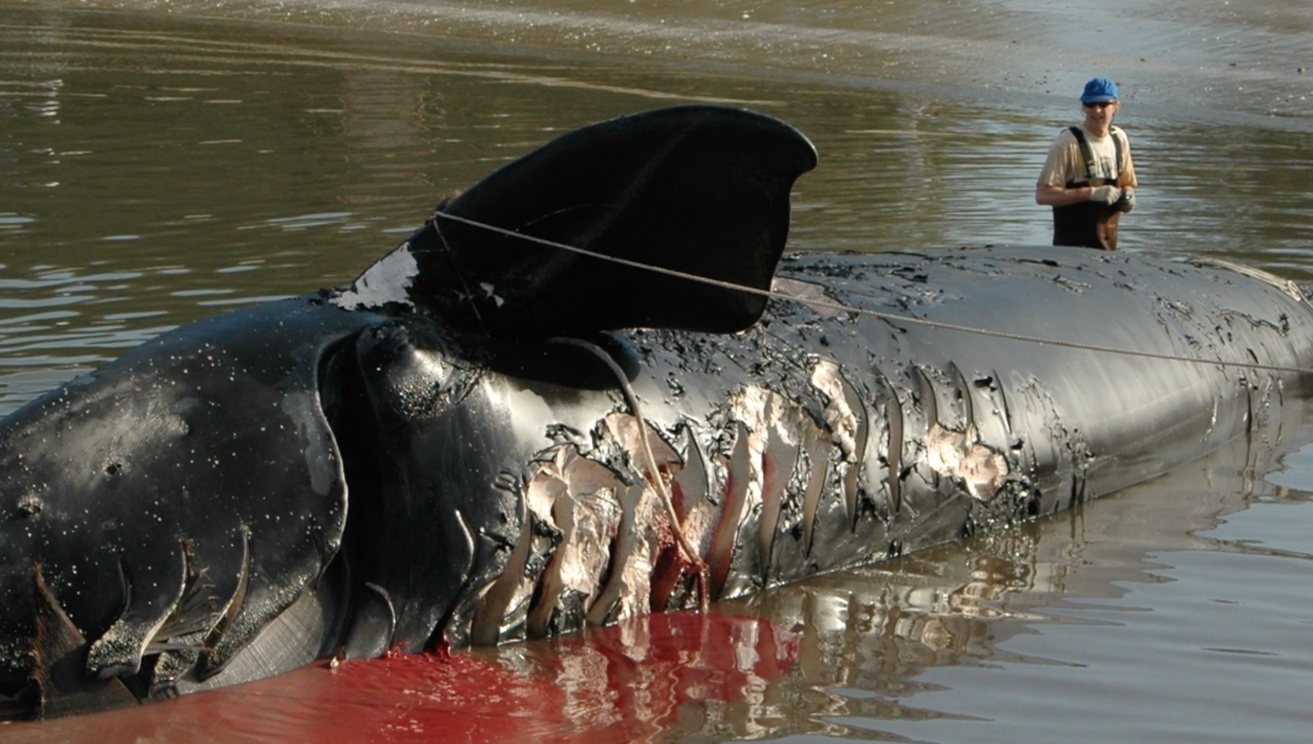

Appendix B: one image of a ship strike injured humpback whale photographed January 2018 by expedition staff Adrian Boyle in the Antarctic Sound (separate email)
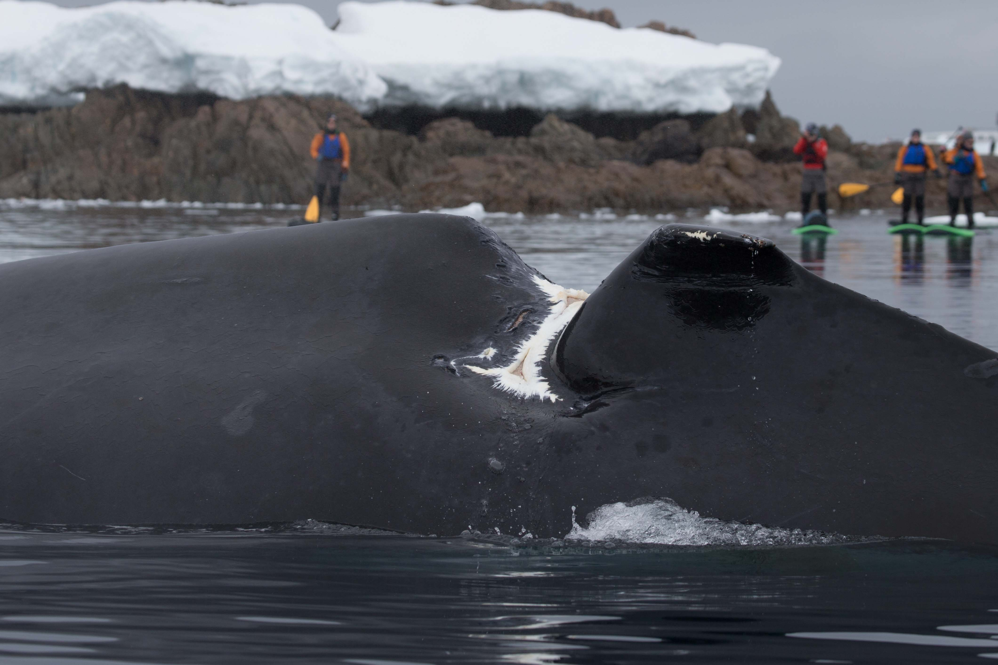

Appendix C: a graph from Conn et al 2013 modeling the probability of a ship strike causing lethal injuries as a function of ship speed
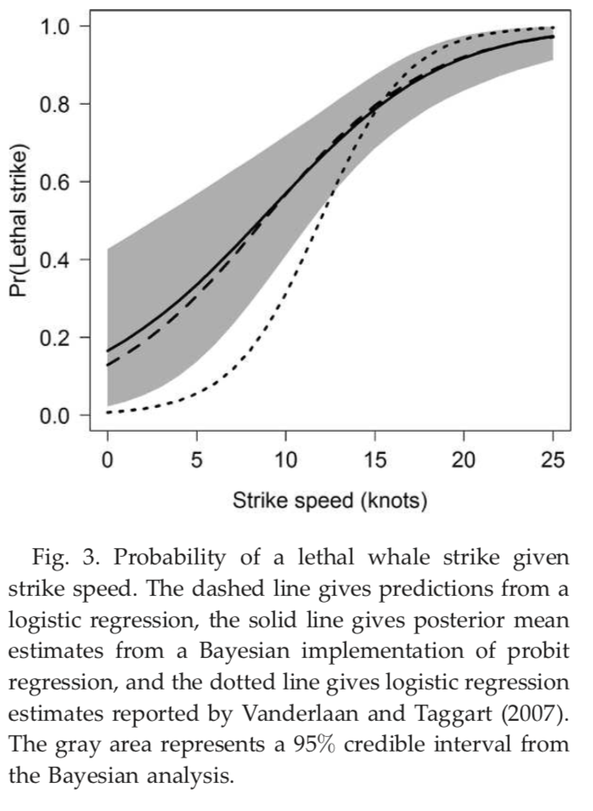

Appendix D: map of the Antarctic Peninsula with locations of humpback whale encounters recorded in the Happywhale database
