IAATO Overview of Antarctic Tourism: A Historical Review of Growth, the 2020-21 Season, and Preliminary Estimates for 2021-22

IAATO Overview of Antarctic Tourism:
A Historical Review of Growth, the 2020-21 Season, and Preliminary Estimates for 2021-22
Information Paper Submitted by the
International Association of Antarctica Tour Operators (IAATO)

Introduction
IAATO is pleased to provide the statistical data compiled from Post Visit Reports for the 2020-21 season.
Due to the SARS CoV-2 pandemic, IAATO Operator expeditions during the 2020-21 season were limited to two individual expeditions, comprised of three yachts. Three IAATO Operators also provided dedicated air or vessel support to National Antarctic Programs.
We also include the preliminary estimates for 2021-22 as of 12 May, 2021. These estimates represent the current best-case operating scenario for the 2021-22 season. However, operations will not only depend on Antarctic Gateway protocols but also on worldwide travel restrictions. We will provide further updates on the 2021-22 season activities to Competent Authorities in October 2021.
In addition to providing our annual overview of IAATO activities to the ATCM we also take this opportunity, in IAATO’s 30th year, to build on discussions with different Treaty Parties around growth and diversification of activities, by including a historical perspective which may aid ongoing discussions. Because 2020-2021 was an irregular season for IAATO, data have been omitted from overall discussions in this paper.
The figures presented throughout this paper are based on information provided to IAATO by its Operators. Visitor numbers reflect only those travelling with IAATO Operator companies and do not include Observers, Government Officials, or those individuals taking part in research projects that are being supported by IAATO Operators.
IAATO’s Membership continues to encompass the majority of private-sector tour operators. Operator activities are permitted or authorized through Environmental Impact Assessments, Advance Notifications and, where relevant, Waste Management Permits, and submitted in advance of the season. Nearly all activities, which follow IAATO policies and guidelines, have been conducted on expeditions for more than two decades, and in many cases since the beginning of Antarctic tourism circa the 1960’s. IAATO Operators continue to work together to coordinate activities in advance, so that operations are conducted in a safe and environmentally responsible manner, and that activities are planned to have no more than a minor or transitory impact on the Antarctic environment.

1.0 Historical Overview
1.1 IAATO Member Activities and Managing for Growth
Prior to the SARS CoV-2 pandemic, the growth of the Antarctic tourism industry was a topic of great interest within the Antarctic and worldwide communities. In three decades, IAATO has seen two other periods of growth - once during the mid-1990s and then again in the period 2003-2008. During each of these periods of growth, and in the intervening ‘lull’ in activities, IAATO has brought in a series of tourism management measures, many of which were subsequently adopted by the ATCM. With advancements in technology, reporting and communications, and building on lessons learned in the past, IAATO has been able to forecast and monitor the current period of growth, making measured decisions and advancements to properly position the organisation as changes happen.

While the pandemic effectively cancelled the industry’s activities for the 2020-2021 season, it is anticipated that when the global pandemic is eventually brought under control, activity levels will eventually bounce back to pre-pandemic levels. Anticipating this eventual return to normal levels of activity, IAATO continues to strengthen, test, and refine the suite of ‘tools’ to ensure the continued successful management of activities.

One of the most recent strengthening of requirements has been a review of field staff experience. In its early years, IAATO established the requirement that 75% of field staff would have previous Antarctic experience. Over the years, the breadth of activities offered have expanded as has the range of operations, requiring a broader range of specialized skills for field staff. With more advanced tools in place, such as the IAATO Online Assessment and the development worldwide of professional standards in guiding and other activities, this benchmark has been reviewed to recognise and reflect this development. As of the 2021-22 season, in accordance with IAATO Bylaws, Operators are required to hire a sufficient number of expedition staff, at least 80% of whom have previous professional guiding experience relevant to their specific role (e.g. kayak guide, small boat drivers) and 50% of whom have previous Antarctic experience, as agreed by IAATO definition. Organizers also are required to ensure that all field staff in their employ take and pass the relevant IAATO online assessment module.

Figures 1.1 – 1.3 give an overview of some of the key growth management tools introduced by IAATO during three periods of growth between 1993-2021.

Figure 1.1: Examples of IAATO management tools introduced in response to growth between 1993 and 2001

Ship Scheduler Development
Site Guidelines Development
Site Monitoring & Reporting Scheme
IAATO Vessel Tracking
Wilderness Etiquette
Yacht Outreach Program
Voluntary Field Staff Assessments

Figure 1.2: Examples of IAATO management tools introduced in response to growth between 2001 and 2012

Mandatory Whale Avoidance Requirements
Live Ship Scheduler and New Database
Mandatory Field Staff Assessments
Expansion of Mandatory Observer Scheme
Code of Conduct
Systematic Conservation Plan
Additional Activity Guidelines
Enhanced Field Staff Experience requirements
Figure 1.3: IAATO management tools introduced in response to growth between 2010 – Present

1.2 IAATO Member Nationalities

Reflecting on the latest period of growth, the Post Visit Reports submitted to IAATO indicate the top 10 nationalities who visited Antarctica has remained relatively consistent over the last ten seasons, although proportionately, China has seen the greatest increase in travelers to Antarctica. An overview of the last 10 years can be found in Figure 2: Top 10 Passenger nationalities travelling with IAATO operators between 2010-2020.

Figure 2: Top 10 Passenger nationalities travelling with IAATO operators between 2010-2020

2.0 IAATO Seaborne Operations Overview
This section focuses on IAATO Seaborne Operations.

2.1 IAATO Seaborne Activities
For the last 30 years shipborne tourism on the Peninsula has been the dominant vector of travel. The vast majority of tourism voyages (98%) operate in the Antarctic Peninsula region during the five-month austral summer season (from November to March), and depart from Ushuaia, Argentina or, to a lesser extent, from other ports north of the Antarctic Treaty Area.
Currently, to the best of our knowledge, all commercial SOLAS passenger ship Operators conducting tourism activities in the Antarctic Treaty Area are members of IAATO. Table 1. 10-Year Statistics of Recorded Seaborne Tourism (including Yachts and Cruise Only) offers a summary of the last decade of both IAATO SOLAS and non-SOLAS vessel tourism.
Table 1. 10-Year Statistics of Seaborne Tourism (including Yachts and Cruise Only)
Based on IAATO Post Visit Reports.

Year | No. of operators | No. of ships &  yachts | No. of voyages | No. of passengers making landings | No. of cruise only passengers
2010-11 | 41 | 47 | 223 | 19,065 | 14,373
2011-12 | 36 | 41 | 234 | 21,131 | 4,872
2012-13 | 39 | 45 | 258 | 24,892 | 9,070
2013-14 | 42 | 51 | 283 | 27,374 | 9,670
2014-15 | 37 | 44 | 268 | 26,812 | 9,459
2015-16 | 38 | 48 | 286 | 29,960 | 8,109
2016-17 | 38 | 47 | 298 | 36,440 | 7,475
2017-18 | 44 | 50 | 344 | 42,576 | 9,131
2018-19 | 44 | 56 | 360 | 44,600 | 10,889
2019-20 | 47 | 62 | 408 | 55,164 | 18,506
2020-21 | 2 | 3 (Yachts) | 2 | 15 | 0
IAATO vessel Operators maintain a minimum of 20:1 field staff to passenger ratio when ashore. Staff and guides assist in the preparation of policies and guidelines and ensure that they are implemented both in the field, and through educational programmes on board.

2.3 Scope of IAATO Seaborne Activities
Commercial tourist activities included the operation of small inflatable boats (Zodiac, Polar Cirkle Boats, R.I.B., Naiad, hovercraft, etc.), shore landings, and to a lesser extent activity such as, but not limited to, kayaking, climbing, and short overnight stays. Most of these activities have taken place for a minimum of 20 years with some dating back to the beginning of Antarctic tourism in the 1960’s.
Through the years descriptions and the type of activities have been expanded in the IAATO Post Visit Reports to facilitate greater accuracy for reporting and planning. For instance, RPAS Flights, although banned recreationally in coastal waters by IAATO, has been expanded to differentiate between commercial, scientific, and operational/navigation flights. Likewise, what was once described as swimming, has now been expanded to swimming – distance and polar plunge.
Representing the current expansion of descriptions during this last period of growth, Figure 3: Commercial Operated Activities Conducted from Expedition Vessels and Yachts for 2019-20 illustrates activities offered by IAATO vessels including cruise-only and yachts, for 2019-2020. Small boat cruising and landing remain the most popular activities (58%) for vessels offering landings, while scenic ship cruising for both landing and cruise-only vessels also remains a key activity. A range of other activities (e.g. kayaking and short overnight stays) contribute to a smaller portion (9%) of off-ship activities. Looking ahead it is anticipated that ship cruising, small boat cruising and small boat landings will continue to be the dominant activity and other activities will remain small scale in comparison.
For more information on IAATO Operator activities see ATCM XLII IP145 A Catalogue of IAATO Operator Activities.
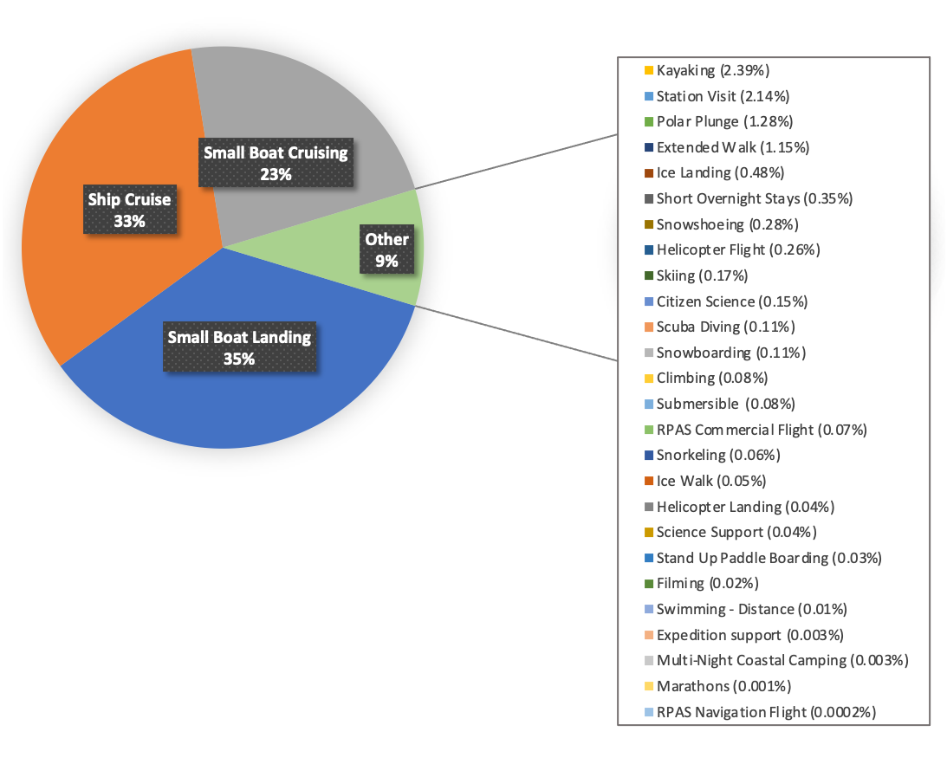
Figure 3: Commercial Operated Activities Conducted from Expedition Vessels and Yachts for 2019-20

3.0 IAATO Deep Field and Air Tourism Overview

Five IAATO Operators conduct deep field tourism activities and one air Operator, which also supports air-cruise operations, offers single day or multi-day Antarctic experiences in the South Shetland Islands. Table 2. IAATO Deep Field and Air Operators Main Camps and Main Area of Operation provides an overview of Deep Field and Air Operators primary areas of operation/base camp. Deep Field Operators also utilise satellite field camps and runways for their different activities and flights. Figure 4: Deep Field and Air Operator Clients 2010-2021 gives an overview of the deep field and air client numbers for the last decade. Table 3: Programs and Participant Numbers (clients) for 2015-20 offers additional information of those operations.

Table 2. IAATO Deep Field and Air Operators Main Camps and Main Area of Operation
Deep Field and Air Operators | Main Camp or Runway | Main Area of Operation
Antarctic Logistics and Expeditions (ALE) | Union Glacier | West Antarctica to South Pole
Arctic Trucks | Union Glacier and Dronning Maud Land | Dronning Maud Land, West Antarctica to South
Ice Trek Expeditions | Union Glacier and Dronning Maud Land | Dronning Maud Land, West Antarctica to South
The Antarctic Company (TAC) | Dronning Maud Land | Dronning Maud Land to South Pole
White Desert (WDL) | Dronning Maud Land | Dronning Maud Land to South Pole
Aerovias DAP | King George Island | King George Island

Figure 4: Deep Field and Air Operator Clients 2010-2021
Deep Field and Air Operators usually maintain a higher client to staff ratio than is typical for seaborne tourism, often one guide to every three clients. The exception is with solo expeditions, for example during South Pole Ski Expeditions, where the clients are supported remotely and closely monitored through communication protocols. All Deep Field and Air Operators prepare contingency plans for the health, safety, medical care and evacuation or their staff and clients, in line with ATCM Resolution 6(2017).

3.1 Deep Field Operator Programs and Activities
Activities including the operation of standard programs, the organization and operation of private expeditions, and logistical support of other expeditions for the last five seasons, are outlined in Table 3: Programs and Participant Numbers (clients) for 2015-20. Total numbers participating include clients from all five IAATO Deep Field Operators. Note that some clients participated in multiple programs. Most activities detailed below have been offered consistently since the 1990’s and have not changed in this latest period of growth. Additionally, activities for air Operator Aerovias DAP are listed for seasons 2018 – 2020, reporting on their activities since becoming an IAATO Member.

Table 3: Programs and Participant Numbers (clients) for 2015-20
(Note: some participants may take part in several programs)
Program | 2015-16 | 2016-17 | 2017-18 | 2018-19 | 2019-20
Emperor Penguin Colony Visits | 45 | 50 | 94 | 142 | 189
Deep Field Experiences (camping, skiing, mountaineering, skydiving, cycling, etc.) | 60 | 51 | 88 | 44 | 243
Deep Field Flights (e.g. to Pole of Inaccessibility) | 21 | 4 | 0 | 17 | 25
South Pole Fly-in | 107 | 71 | 100 | 172 | 278
South Pole Ski Expedition | 7 | 12 | 18 | 18 | 37
South Pole Motorised Expedition | 0 | 15 | 3 | 22 | 18
Last 1-2 Degree Expedition | 30 | 43 | 44 | 43 | 117
Antarctic Crossing (ski & motorised) | 2 | 18 | 7 | 0 | 27
Vinson Massif | 143 | 111 | 145 | 152 | 399
Marathon | 80 | 113 | 124 | 120 | 317
Day Trips King George Island |  |  |  | 112 | 123

4.0 Preliminary Estimate of Planned Activities for the 2020-21 Season
The 2020-21 season of Antarctic tourism was effectively cancelled as a result of the SARS CoV-2 pandemic. How and when the industry will recover is yet to be seen, but the pandemic will continue to affect IAATO Operator activities for the 2021-22 season and possibly beyond. The preliminary estimates in Appendix 2 represent the current best-case operating scenario for the 2021-22 season should the majority of travel restrictions be removed. Operations will depend on both Antarctic Gateway protocols and worldwide travel restrictions and/or protocols. We will provide further updates on the 2021-22 season activities to Competent Authorities in October 2021.

5.0 Tourism Statistics
The following data is publicly available on the IAATO website (https://iaato.org/information-resources/data-statistics/visitor-statistics/). In order to better assist with delivering appropriate statistics for interested parties, those who wish to access the IAATO tourism statistics must now do so through a data access portal.
- Tourists by Nationality (Landed)
- Tourists by Nationality (Air and Cruise)
- Tourists by Nationality (All)
- Number of Vessel based Tourists per Site per Activity – Ross Sea Region
- Number of Vessel based Tourists per Site per Activity – Peninsula
- Number of Vessel based Tourists per Site per Activity – All Regions

Appendices:
- Appendix 1: Overview of Antarctic Tourism 2020 – 21
- Appendix 2: Preliminary Estimate of Antarctic Tourism 2021-2022 (As of May 11, 2021)

Appendix 1: Overview of Antarctic Tourism 2020 – 21

SUMMARY OF ACTUALS for 2020-2021 SEASON
(All tourist types)
*Note all numbers and company status are subject to change and are based on reports as of
Types of Tourism | Number of Vessels | Number of Departures | Total Number of Passengers
IAATO Traditional Seaborne Tourism Peninsula | 0 | 0 | 0
IAATO Seaborne Tourism Ross Sea / Continental | 0 | 0 | 0
IAATO Sailing Vessels / Yacht Tourism Peninsula | 1 | 1 | 9
IAATO Air-Cruise Peninsula | 2 | 2 | 6
IAATO Large Ships/ Cruise - Only Peninsula | 0 | 0 | 0
IAATO Deep - Field Tourism | 0 | 0 | 0

IAATO Members Air-Cruise Tourism - Peninsula Region - 2020-2021
Vessel | Operator / Charterer | Actual # Voyages | Actual # of Passengers
Explorer | Spirit of Sydney Expeditions | 1 | 0
Voyager | Spirit of Sydney Expeditions | 1 | 6
Total |  | 2 | 6
IAATO Members Yacht Tourism - Peninsula Region - 2020-2021
Vessel | Operator / Charterer | Actual # Voyages | Actual # of Passengers
S/V Australis | Ocean Expeditions Ltd | 1 | 9
Total |  | 1 | 9

Appendix 2: Preliminary Estimate of Antarctic Tourism 2021-2022 (As of May 11, 2021)

SUMMARY OF ESTIMATES for 2021-2022 SEASON
(All tourist types)
*Note all numbers and company status are subject to change and are preliminary estimates only
Types of Tourism | Number of Vessels | Number of Departures | Total Number of Passengers
IAATO Traditional Seaborne Tourism Peninsula | 39 | 333 | 46953
IAATO Seaborne Tourism Ross Sea / Continental | 5 | 9 | 1138
IAATO Sailing Vessels / Yacht Tourism Peninsula | 10 | 26 | 212
IAATO Air-Cruise Peninsula | 8 | 61 | 3375
IAATO Large Ships/ Cruise - Only Peninsula | 2 | 4 | 7500
IAATO Deep - Field Tourism | 4 Operators | Varies | 634

IAATO Members Traditional Seaborne Tourism - Peninsula Region - 2021-2022
Vessel | Operator / Charterer | Est. # Voyages | Est. # of Passengers
Bark Europa | Rederij Bark EUROPA B.V. | 5 | 160
Corinthian | Grand Circle Corporation | 9 | 774
Expedition | G Adventures | 13 | 1170
Fram | Hurtigruten AS | 9 | 1125
Hamburg | Plantours Kreuzfahrten | 4 | 1000
HANSEATIC inspiration | Hapag-Lloyd Cruises | 4 | 600
HANSEATIC nature | Hapag-Lloyd Cruises | 5 | 750
HANSEATIC spirit | Hapag-Lloyd Cruises | 4 | 600
Hebridean Sky | Noble Caledonia | 3 | 285
Hondius | Oceanwide Expeditions | 12 | 2040
Janssonius | Oceanwide Expeditions | 9 | 1530
L'Austral | Ponant | 11 | 2200
Le Boreal | Ponant | 9 | 1800
Le Commandant Charcot | Ponant | 11 | 2200
Le Lyrial | Abercrombie & Kent USA, LLC | 4 | 640
Le Lyrial | Ponant | 9 | 1800
Legend | EYOS Expeditions Ltd. | 2 | 44
Magellan Explorer | Antarctica21 | 2 | 120
MS Fridtjof Nansen | Hurtigruten AS | 14 | 3500
MS Roald Amundsen | Hurtigruten AS | 10 | 2500
National Geographic Endurance | Lindblad Expeditions | 6 | 570
National Geographic Explorer | Lindblad Expeditions | 9 | 1017
National Geographic Resolution | Lindblad Expeditions | 8 | 760
Ocean Adventurer | Quark Expeditions | 7 | 448
Ocean Atlantic | Albatros Expeditions | 13 | 1950
Ocean Diamond | Quark Expeditions | 10 | 950
Ocean Endeavour | Intrepid Travel | 11 | 1925
Ocean Victory | Albatros Expeditions | 13 | 1950
Ortelius | Oceanwide Expeditions | 8 | 864
Plancius | Cheesemans' Ecology Safaris | 1 | 100
Plancius | Oceanwide Expeditions | 10 | 1080
Scenic Eclipse | Scenic Tours (USA) Inc | 7 | 1400
Sea Spirit | Poseidon Expeditions | 11 | 550
Seabourn Quest | Seabourn Cruise Line Ltd. | 5 | 2150
Seaventure | Polar Latitudes | 10 | 1200
Silver Cloud | Silversea Cruises Ltd. | 7 | 1302
Silver Explorer | Silversea Cruises Ltd. | 7 | 742
Sylvia Earle | Aurora Expeditions | 6 | 396
Ultramarine | Quark Expeditions | 11 | 1100
Ushuaia | Antarpply Expeditions | 13 | 715
World Explorer | Quark Expeditions | 11 | 946
Total |  | 333 | 46953

IAATO Members Air-Cruise Tourism - Peninsula Region - 2021-2022
Vessel | Operator / Charterer | Est. # Voyages | Est. # of Passengers
Magellan Explorer | Antarctica21 | 16 | 960
MY Hans Hansson | Quixote Expeditions | 5 | 60
Ocean Adventurer | Quark Expeditions | 7 | 448
Ocean Nova | Antarctica21 | 13 | 780
S/V Ocean Tramp | Quixote Expeditions | 7 | 49
Silver Explorer | Silversea Cruises Ltd. | 4 | 424
Sylvia Earle | Aurora Expeditions | 6 | 396
World Explorer | Quark Expeditions | 3 | 258
Total |  | 61 | 3375

IAATO Members Yacht Tourism - Peninsula Region - 2021-2022
Vessel | Operator / Charterer | Est. # Voyages | Est. # of Passengers
La Datcha | EYOS Expeditions Ltd. | 2 | 24
MY Hanse Explorer | "Hanse Explorer" GmbH and Co. KG | 5 | 50
Naia | EYOS Expeditions Ltd. | 1 | 12
S/V Icebird | Icebird Expeditions | 3 | 15
S/V Podorange | Voile Australe | 2 | 12
S/V Santa Maria Australis | SIM Expeditions | 3 | 18
S/V Selma Expeditions | Selma Expeditions | 3 | 24
S/V Spirit of Sydney | Spirit of Sydney Expeditions | 3 | 21
S/V Vaïhéré | Latitude Oceane | 3 | 30
S/Y YPAKE II | SUR Expeditions | 1 | 6
Total |  | 26 | 212

IAATO Cruise Only Tourism - Peninsula Region - 2021-2022
Vessel | Operator / Charterer | Est. # Voyages | Est. # of Passengers
Volendam | Holland America Line | 1 | 1500
Westerdam | Holland America Line | 3 | 6000
Total |  | 4 | 7500

IAATO Members Seaborne Tourism – Continental/Ross Sea - 2021-2022
Vessel | Operator / Charterer | Est. # Voyages | Est. # of Passengers
Greg Mortimer | Aurora Expeditions | 3 | 198
HANSEATIC inspiration | Hapag-Lloyd Cruises | 1 | 150
Le Commandant Charcot | Ponant | 1 | 200
Le Soleal | Ponant | 2 | 400
National Geographic Endurance | Lindblad Expeditions | 2 | 190
Total |  | 9 | 1138

IAATO Members Deep-Field Tourism - 2021-2022
Operator / Charterer | Antarctic Area Visited | Est. # Expeditions | Est. # of Passengers
Antarctic Logistics & Expeditions LLC | Continent | Varies | 384
Icetrek Expeditions and Equipment | Continent | Varies | 10
The Antarctic Company (TAC) (Pty.) Ltd. | Continent | Varies | 30
White Desert Ltd | Continent | Varies | 210
Total |  |  | 634

